University of Central Missouri

Department of Computer Science & Cybersecurity

CS5720 Neural network and Deep learning

Fall 2026

Home Assignment 2.

Student name: Ruyi Gai

Submission Requirements:
- Total Points: 100
- Once finished your assignment push your source code to your repo (GitHub) and explain the work through the ReadMe file properly. Make sure you add your student info in the ReadMe file.
- Submit your GitHub link and video on the Bright Space.
- Comment your code appropriately IMPORTANT.
- Any submission after provided deadline is considered as a late submission.

Q1: Implementing an RNN for Text Generation

Task: Recurrent Neural Networks (RNNs) can generate sequences of text. You will train an LSTM-based RNN to predict the next character in a given text dataset.

- Load a text dataset (e.g., "Shakespeare Sonnets", "The Little Prince").
- Convert text into a sequence of characters (one-hot encoding or embeddings).
- Define an RNN model using LSTM layers to predict the next character.
- Train the model and generate new text by sampling characters one at a time.
- Explain the role of temperature scaling in text generation and its effect on randomness.

Hint: Use tensorflow.keras.layers.LSTM() for sequence modeling.
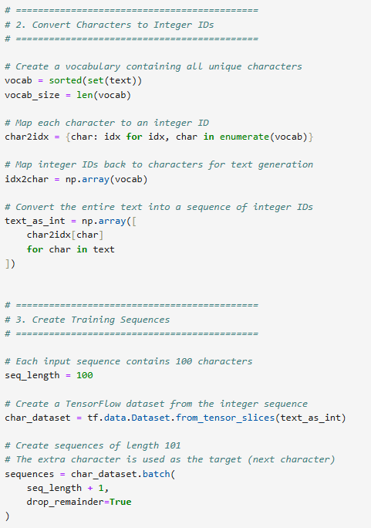
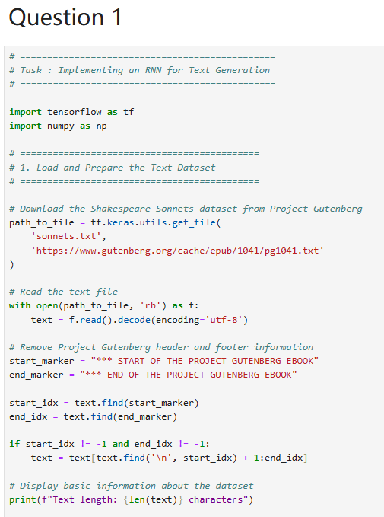

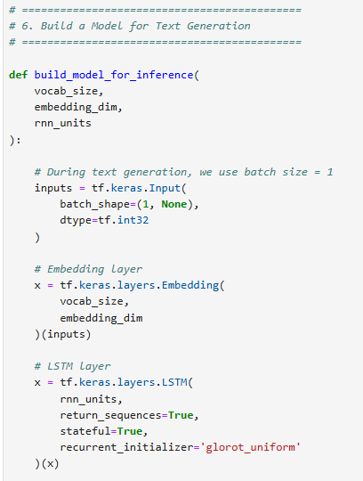
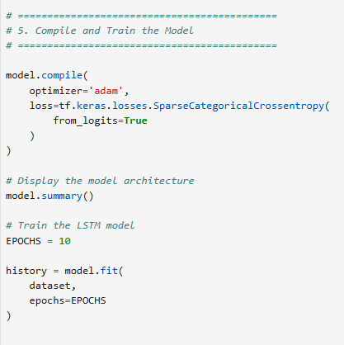
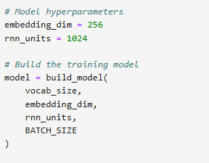
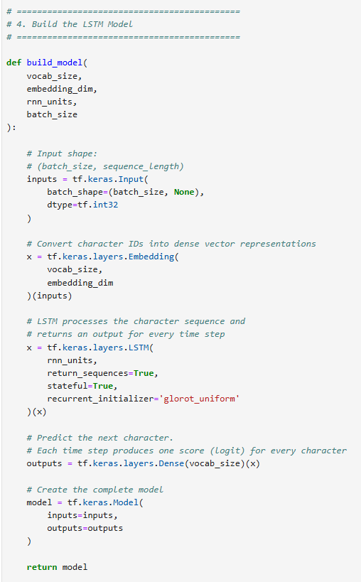
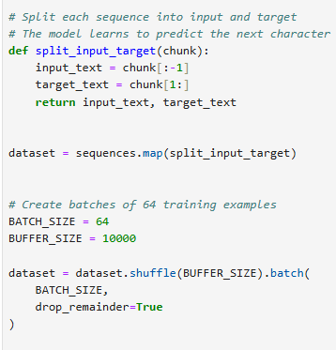

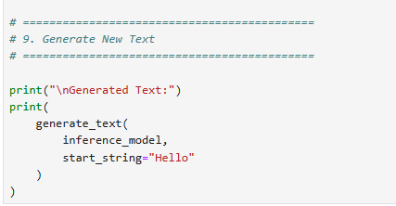
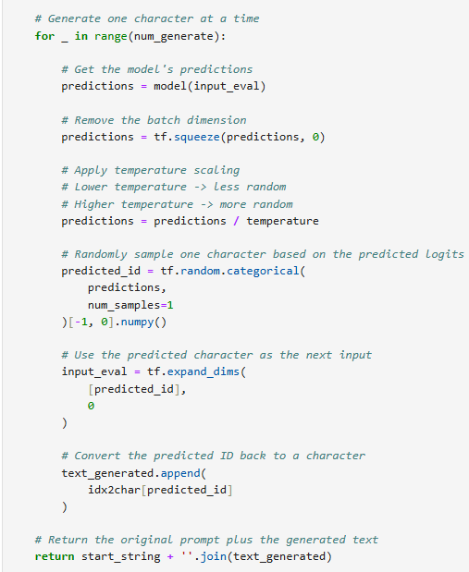
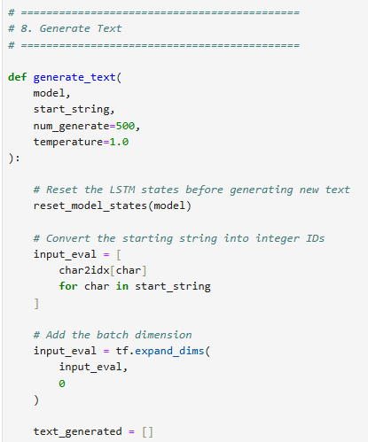
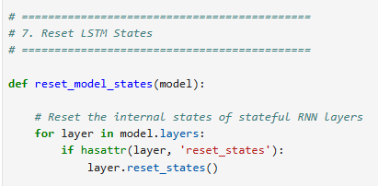
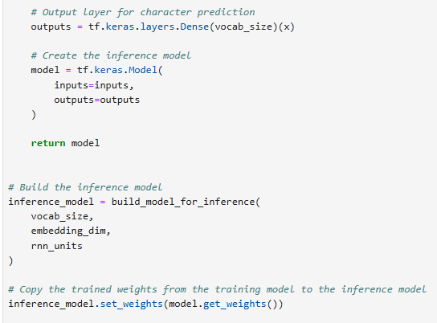
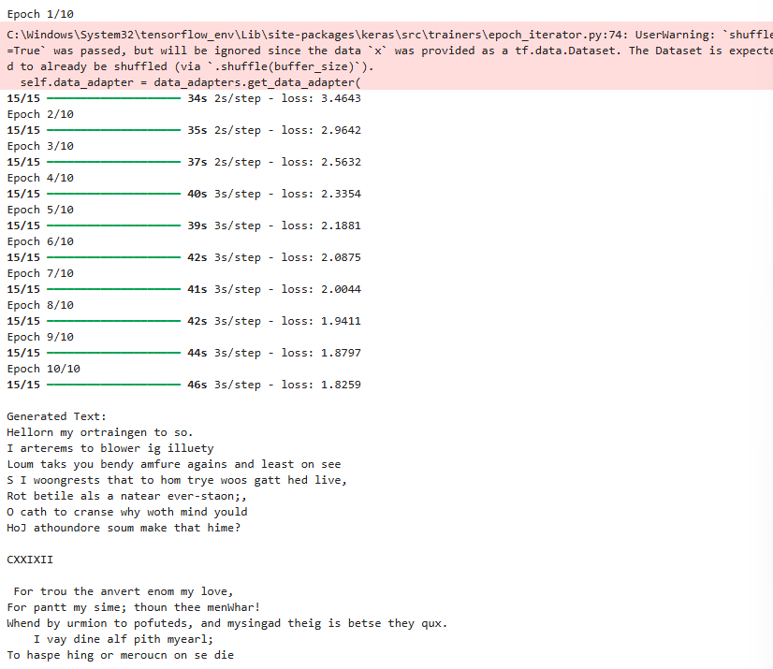
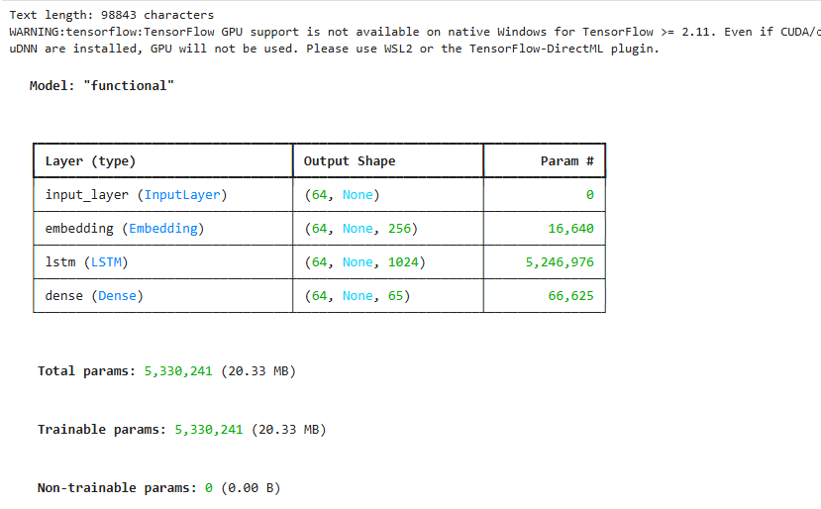
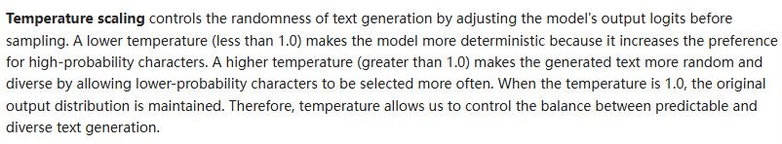

Q2: Sentiment Classification Using RNN

Task: Sentiment analysis determines if a given text expresses a positive or negative emotion. You will train an LSTM-based sentiment classifier using the IMDB dataset.

- Load the IMDB sentiment dataset (tensorflow.keras.datasets.imdb).
- Preprocess the text data by tokenization and padding sequences.
- Train an LSTM-based model to classify reviews as positive or negative.
- Generate a confusion matrix and classification report (accuracy, precision, recall, F1-score).
- Interpret why precision-recall tradeoff is important in sentiment classification.

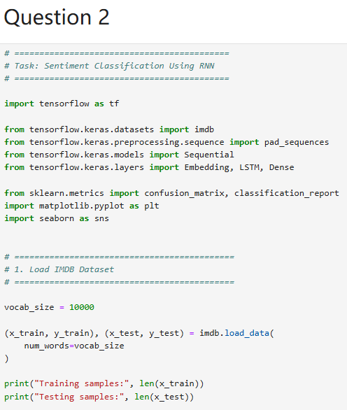
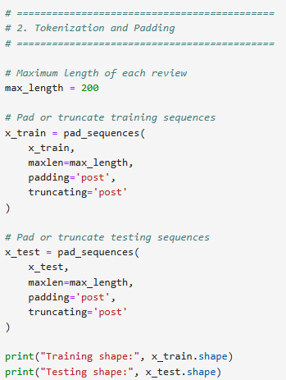
Hint: Use confusion_matrix and classification_report from sklearn.metrics.
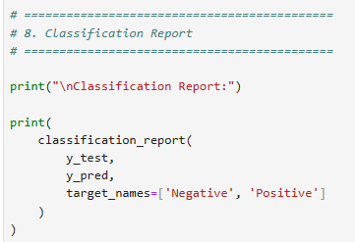
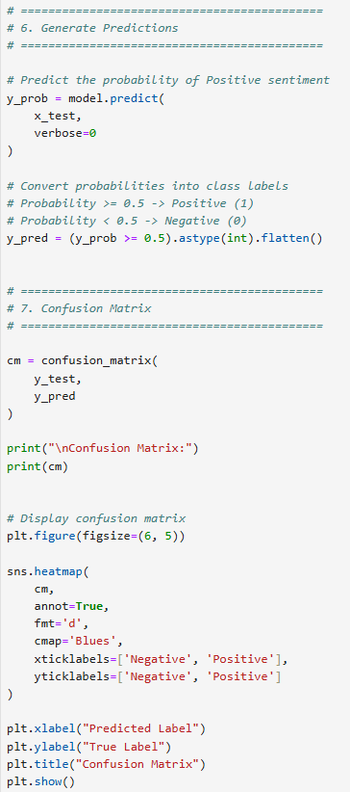
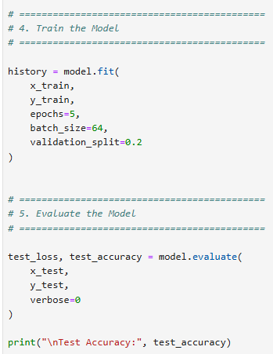
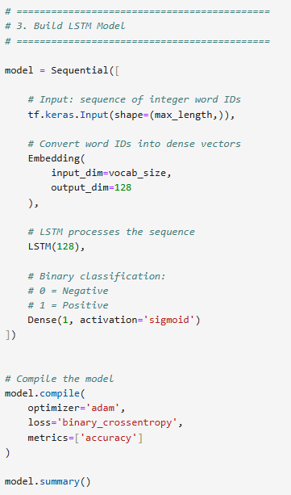

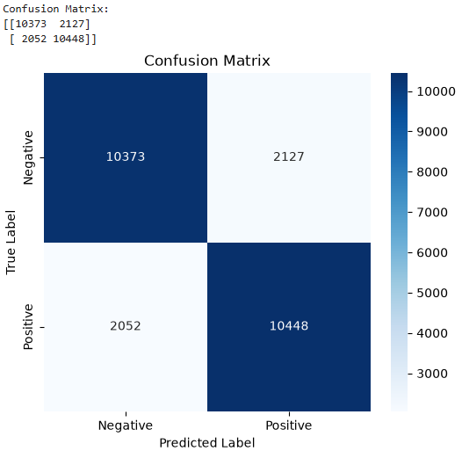
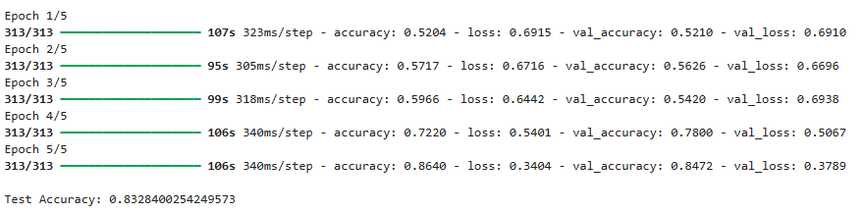
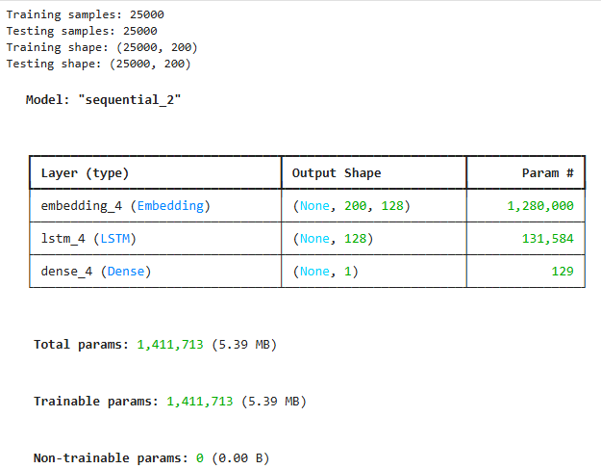
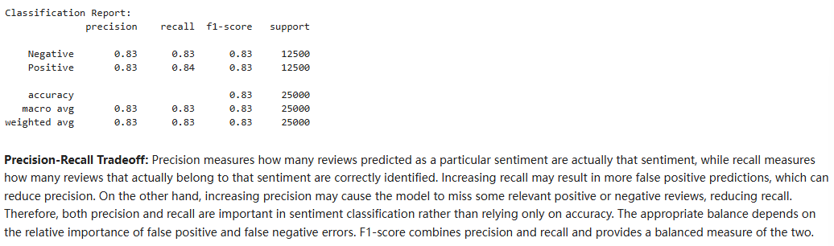

Question 3: Convolution Operations with Different Parameters

Task: Implement Convolution with Different Stride and Padding
Write a Python script using NumPy and TensorFlow/Keras to perform convolution on a 5×5 input matrix using a 3×3 kernel with varying parameters.
- Define the following 5×5 input matrix:
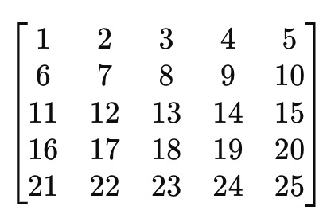
- Define the following 3×3 kernel:
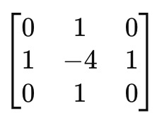
- Perform convolution operations with:
  - Stride = 1, Padding = ‘VALID’
  - Stride = 1, Padding = ‘SAME’
  - Stride = 2, Padding = ‘VALID’
  - Stride = 2, Padding = ‘SAME’
- Print the output feature maps for each case.

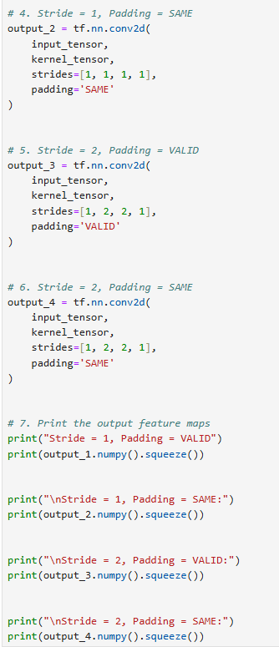
Expected Output
Print the output feature maps for
  - Stride = 1, Padding = ‘VALID’
  - Stride = 1, Padding = ‘SAME’
  - Stride = 2, Padding = ‘VALID’
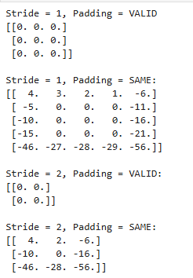
  - Stride = 2, Padding = ‘SAME’
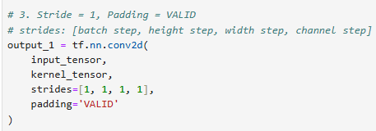
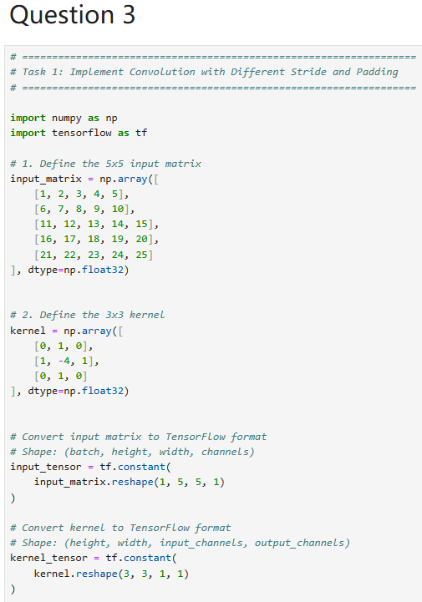

Question 4: CNN Feature Extraction with Filters and Pooling

Task 1: Implement Edge Detection Using Convolution
Write a Python script using NumPy and OpenCV (cv2) to apply edge detection on an image using a Sobel filter.
- Load a grayscale image (you can use any sample image).
- Apply the Sobel filter for edge detection in the x-direction and y-direction.
- Display the original image and the filtered images.
Use the following Sobel filters:

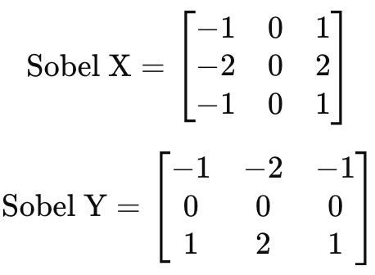

Task 2: Implement Max Pooling and Average Pooling (15 points)
Write a Python script using TensorFlow/Keras to demonstrate Max Pooling and Average Pooling.
- Create a random 4x4 matrix as an input image.
- Apply a 2x2 Max Pooling operation.
- Apply a 2x2 Average Pooling operation.
- Print the original matrix, max-pooled matrix, and average-pooled matrix.

Expected Output
Task1: Edge Detection using Sobel Filter
- Display three images:
  - Original Image
  - Edge detection using Sobel-X
  - Edge detection using Sobel-Y
Task2: Pooling Operations on Random 4×4 Matrix
- Printed original matrix, max pooled matrix, and average pooled matrix.
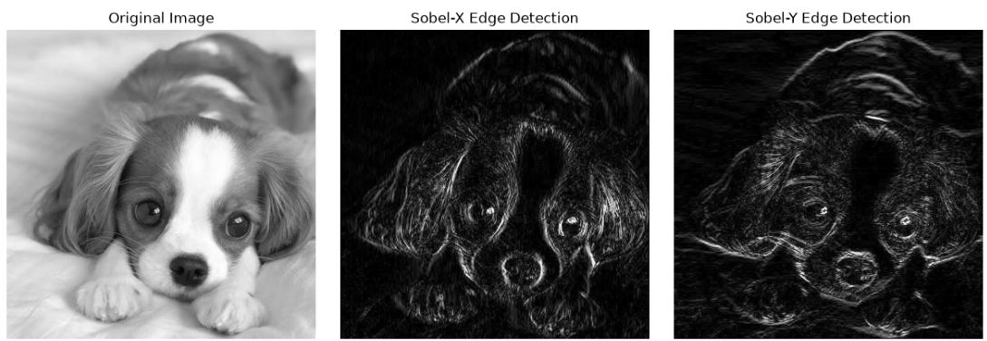
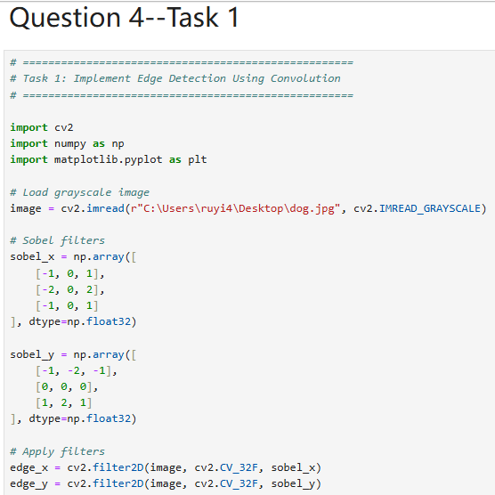
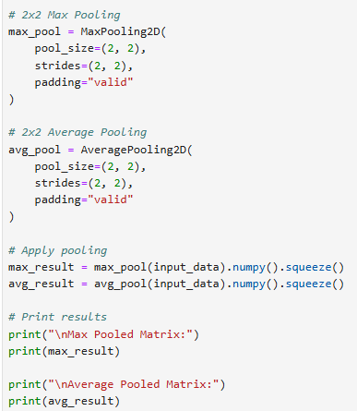
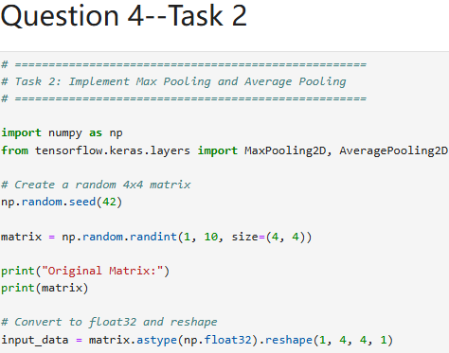
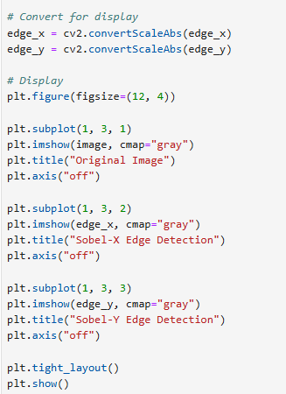
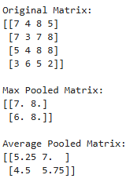

Question 5: Implementing and Comparing CNN Architectures

Task 1: Implement AlexNet Architecture (15 points)
Write a Python script using TensorFlow/Keras to implement a simplified AlexNet model with the following layers:
- Conv2D Layer: 96 filters, kernel size = (11,11), stride = 4, activation = ReLU
- MaxPooling Layer: pool size = (3,3), stride = 2
- Conv2D Layer: 256 filters, kernel size = (5,5), activation = ReLU
- MaxPooling Layer: pool size = (3,3), stride = 2
- Conv2D Layer: 384 filters, kernel size = (3,3), activation = ReLU
- Conv2D Layer: 384 filters, kernel size = (3,3), activation = ReLU
- Conv2D Layer: 256 filters, kernel size = (3,3), activation = ReLU
- MaxPooling Layer: pool size = (3,3), stride = 2
- Flatten Layer
- Fully Connected (Dense) Layer: 4096 neurons, activation = ReLU
- Dropout Layer: 50%
- Fully Connected (Dense) Layer: 4096 neurons, activation = ReLU
- Dropout Layer: 50%
- Output Layer: 10 neurons, activation = Softmax
Print the model summary after defining it.

Task 2: Implement a Residual Block and ResNet (15 points)
Write a Python script to define a Residual Block and use it to build a simple ResNet-like model.
- Implement a function residual_block(input_tensor, filters) that:
  - Takes an input tensor.
  - Applies two Conv2D layers (each with 64 filters, kernel size = (3,3), activation = ReLU).
  - Includes a skip connection that adds the input tensor to the output before activation.
- Create a ResNet model that:
  - Uses an initial Conv2D layer (64 filters, kernel size = (7,7), stride = 2).
  - Applies two residual blocks.
  - Ends with a Flatten layer, Dense layer (128 neurons), and Output layer (Softmax).
Print the model summary after defining it.

Expected Output
The output should display:
- The model summary for AlexNet.
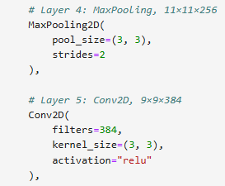
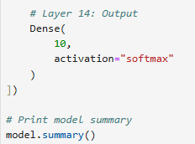
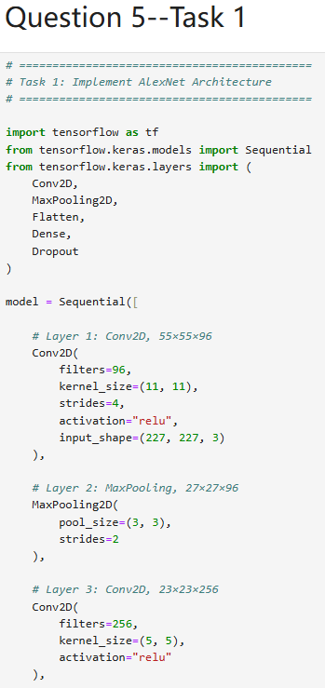
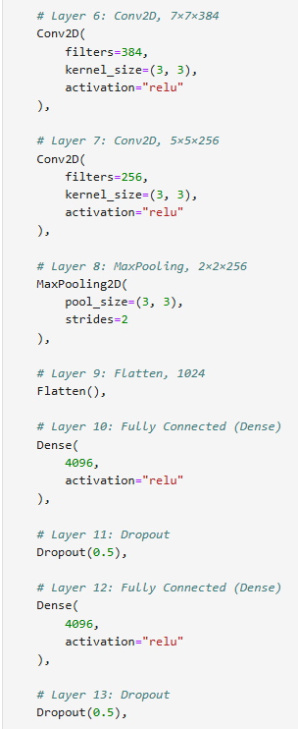
- The model summary for the ResNet-like model.
